**Requirements for the program:**

**System:**   
Any Intel x64 architecture-based CPU

4GB RAM

50MB Storage

Windows Operating System

## **User:**

Should have medium to advanced level knowledge of trading. The user difficulty level of our program is the same as any other trader on the market like Binance or MEXC etc.

**User Manual:**

**Symbols Box**

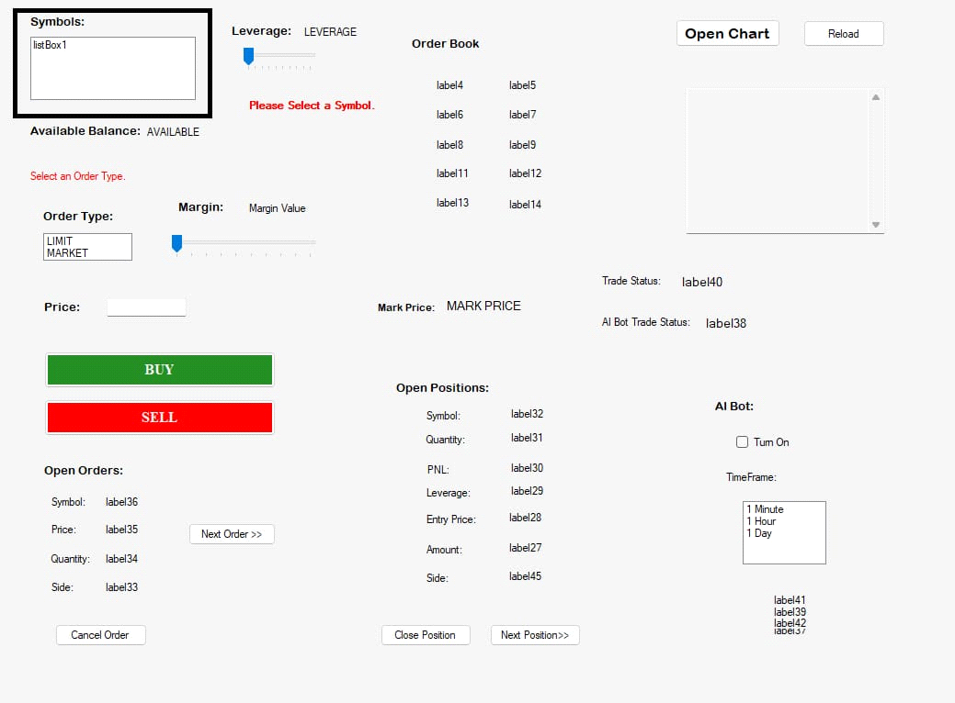

This shows the available symbols for trading. User has to select one symbol then he can proceed his trade.

**Available Balance:**

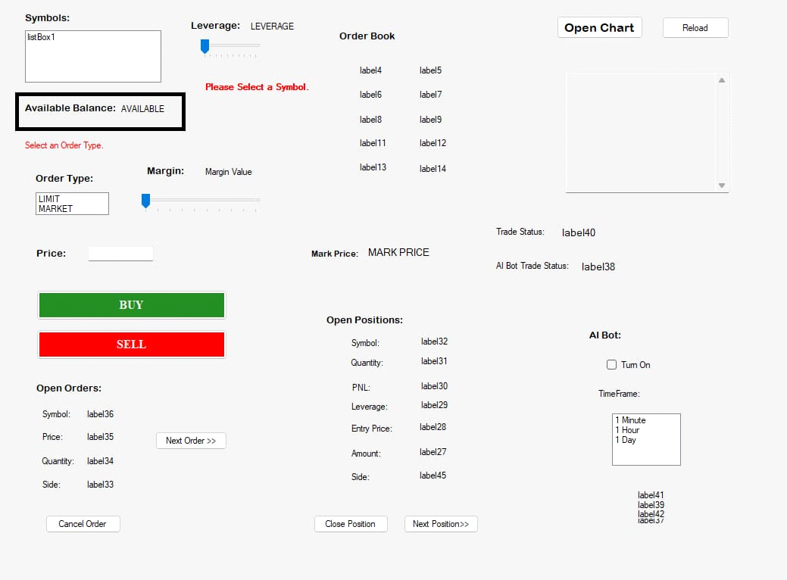

This shows the available balance of user through which he can make trade with, he can use as much balance as he wants in his trade. This is refreshed every 15seconds.

**Select Order Type Message:**

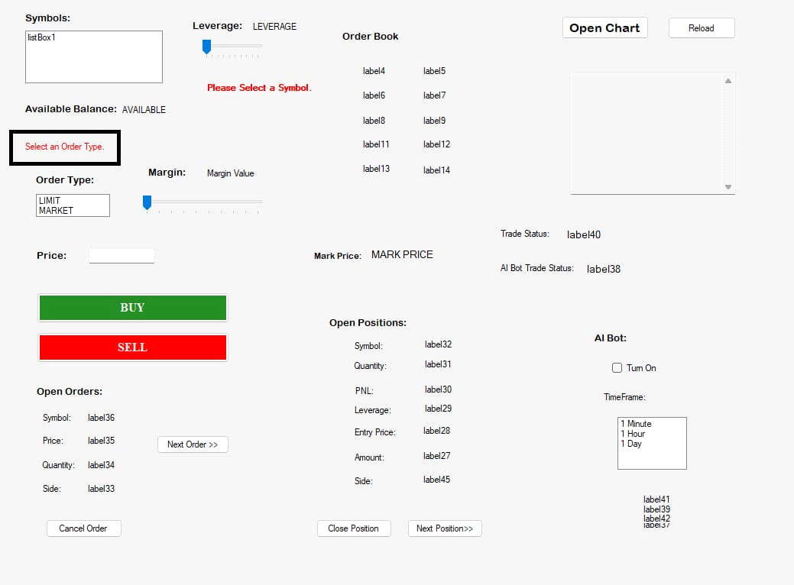

It tells the user to select an order type before trading. Once an order type is selected, it will disappear.

**Leverage:**

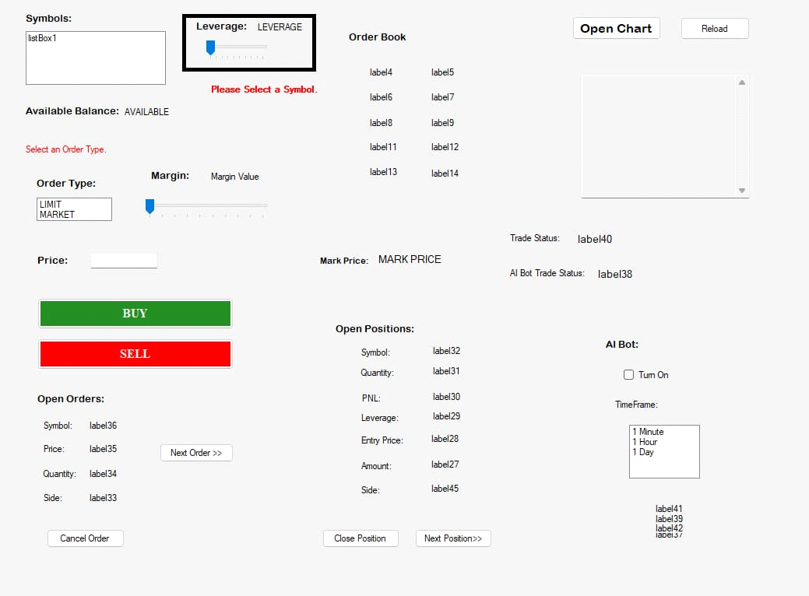

The user can select any leverage he wants. This will remain locked until a valid symbol is not selected.

**Select Symbol Message:**

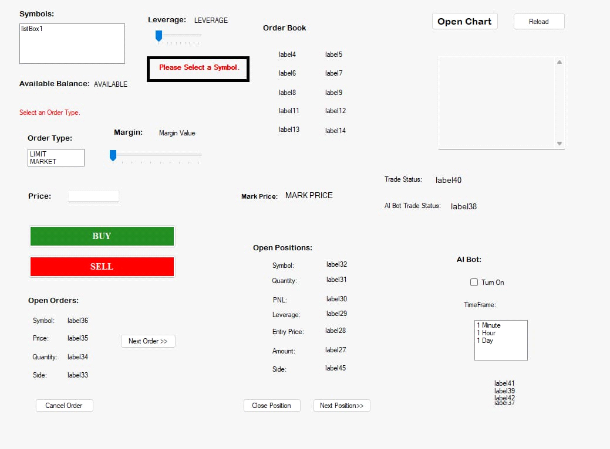

It tells the user to select a symbol before trading. Once a symbol is selected, it will disappear.

**Margin:**

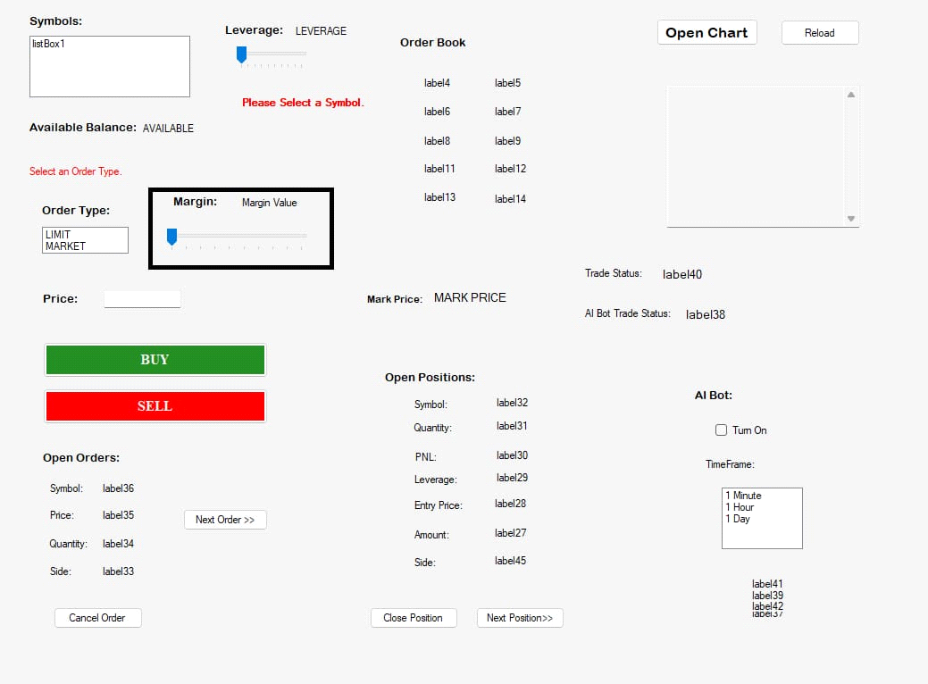

The user can select margin for the trade. It will remain locked until an order type is selected.

**Price Input Box:**

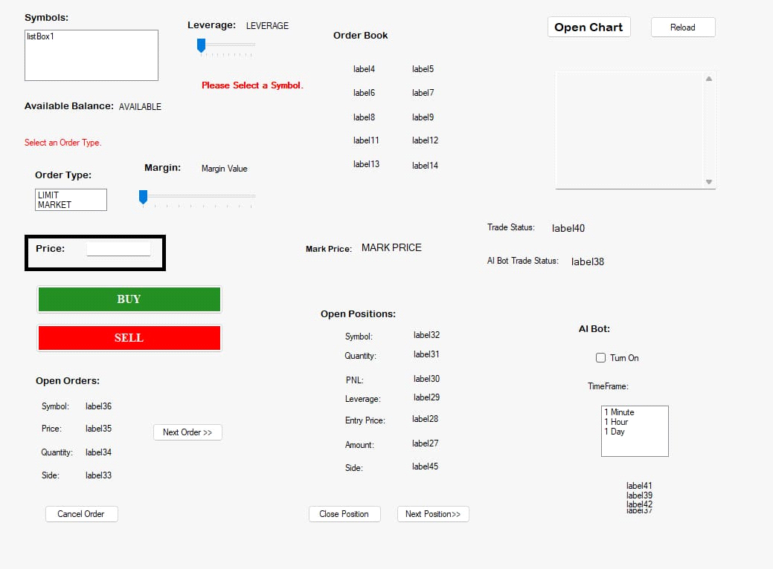

Here user has to enter the price on which want to trade price should be only on LIMIT order type. It will remain locked if the selected order type is MARKET.

**BUY & SELL Buttons:**

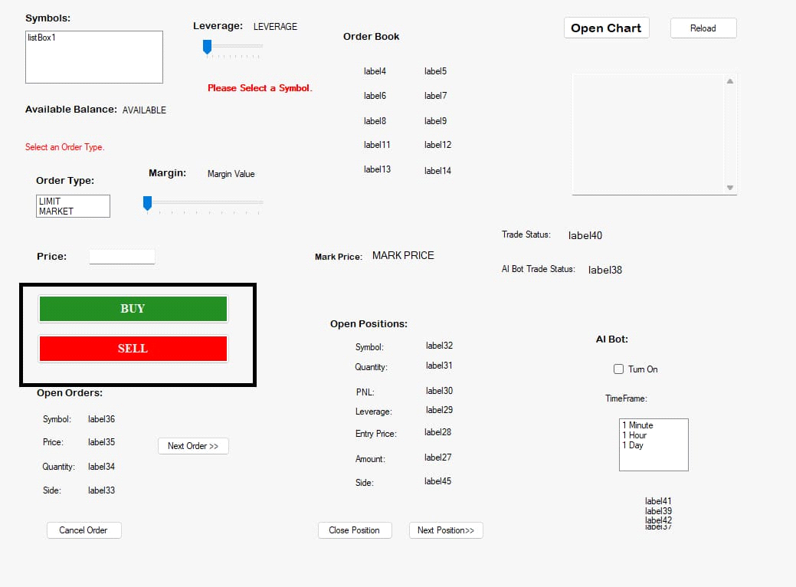

If user want to buy the symbol, then he will click on buy and if he wants to sell then he will click in sell. After clicking the button, a Message would appear in green or red color highlighting the success or failure of the operation performed and disappear soon after. If the trade was successful then the trade would also be stored in the Trades.csv file created in the installation directory.

**Open Orders Display:**

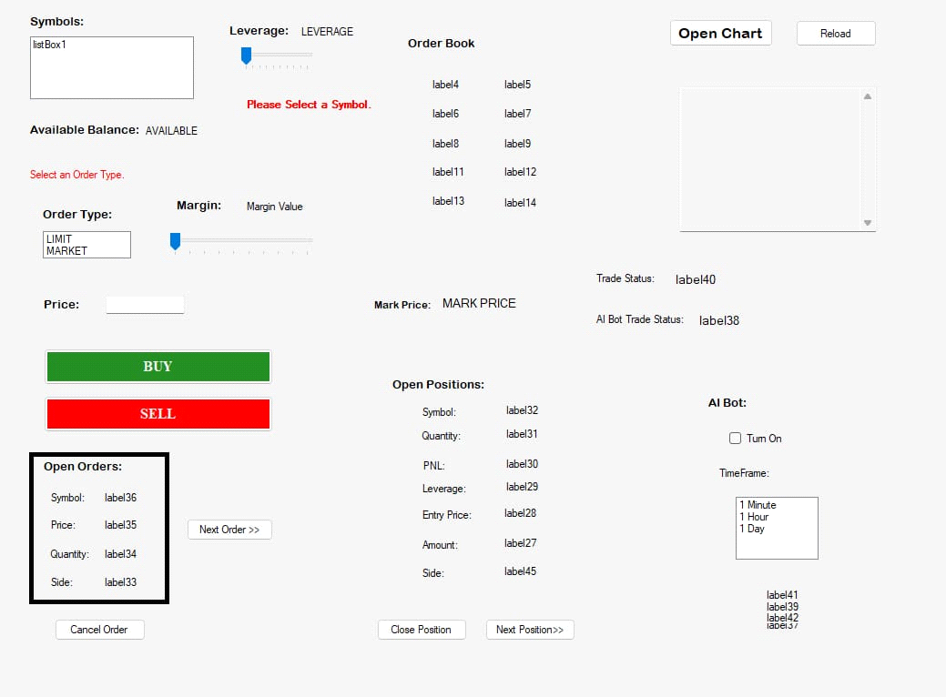

This shows open orders of the user. It shows the symbol, price, quantity and side of the open orders. It is updated every 15 seconds. If there are no open orders then “No Open Orders” is shown.

**Cancel Order Button:**

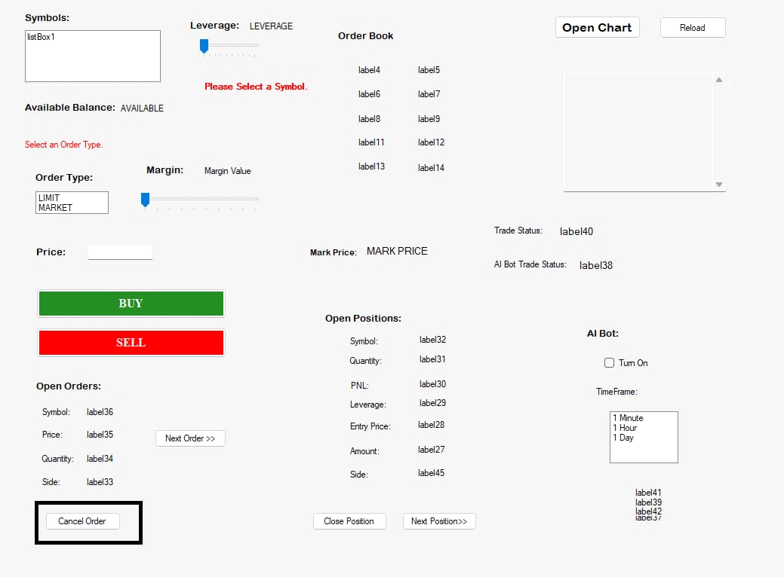

If user want to cancel the order, he can do it by clicking on this button. The order would be cancelled and a message would be shown on the Trade Status bar. If the trade was successful then the trade would also be stored in the Trades.csv file created in the installation directory.

**Next Order Button:**

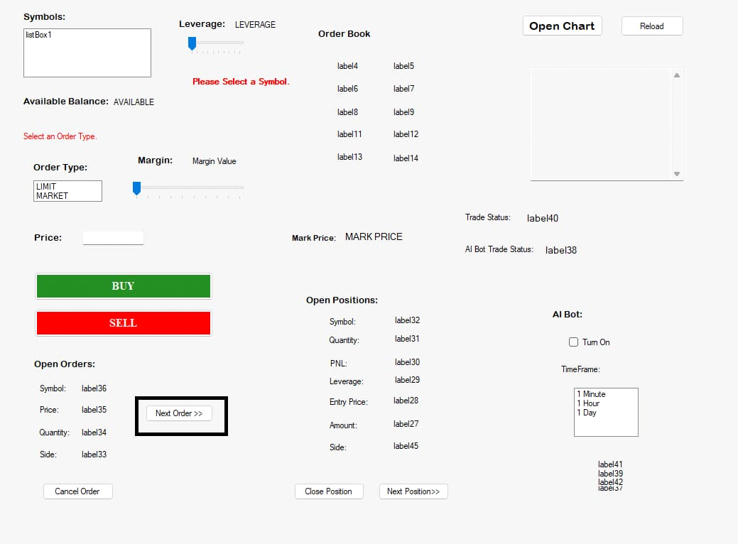

If user wants to the see next order, he can do it by clicking on this.

**Order Book Display:**

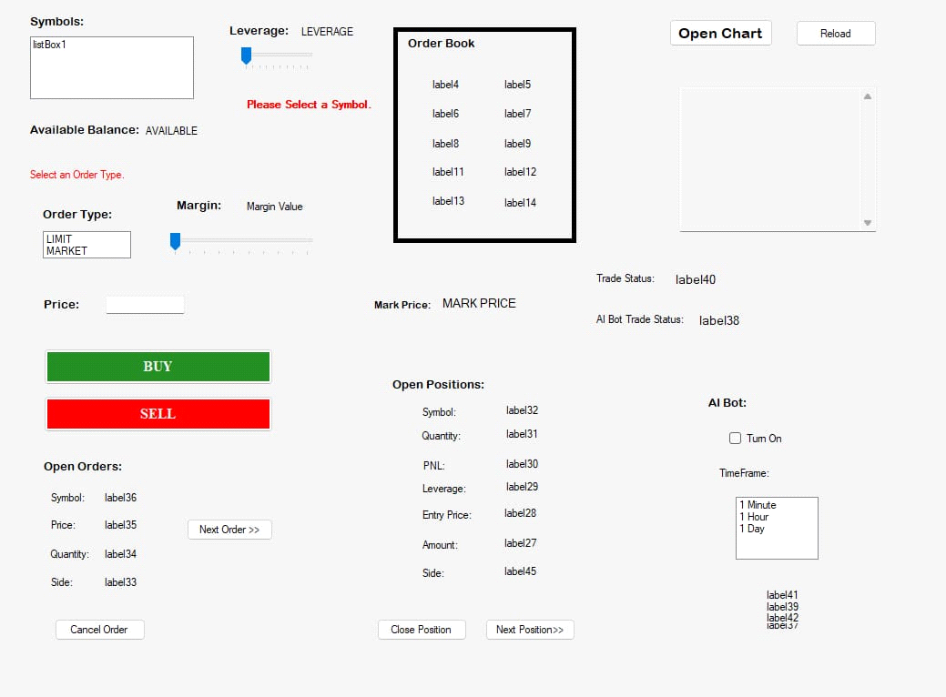

The user can see the order book of the selected symbol. The order book is updated every 15 seconds, and it only starts updating once a valid symbol is selected.

**Market Price:**

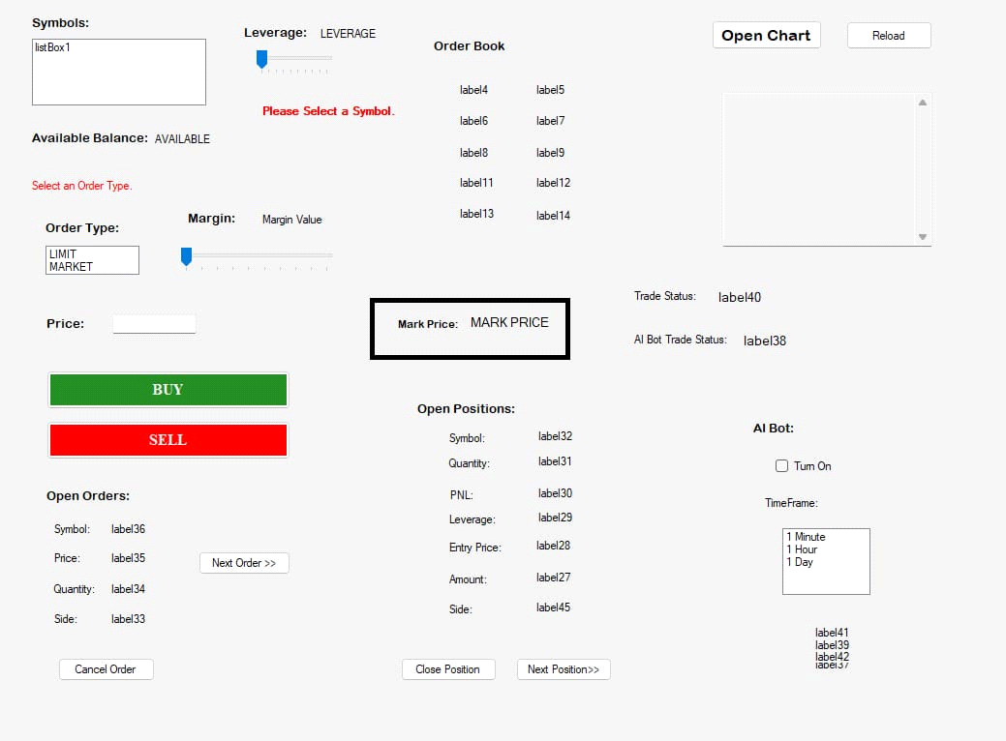

This shows the current MARK price of the selected symbol. The mark price is updated every 15 seconds, and it only starts updating once a valid symbol is selected. If the current market price is less than the previous market price then it will appear in red otherwise it will be green.

**Open Positions Display:**

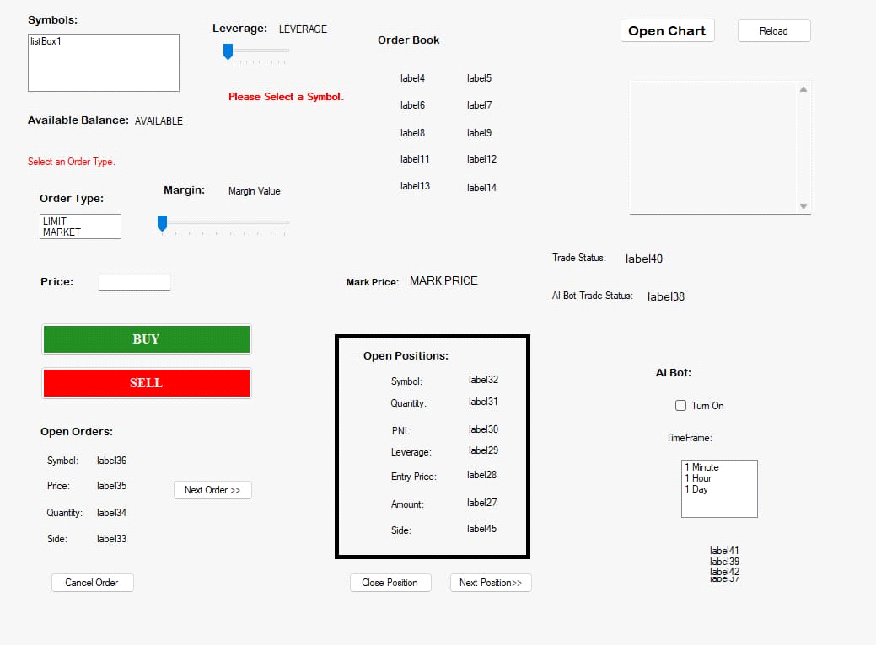

Open position shows the symbol, quantity, PNL, leverage, entry price, amount and side of that open position. This is updated every 15seconds. IF there are no open positions then “No Open Positions” is shown.

**Close Position Button:**

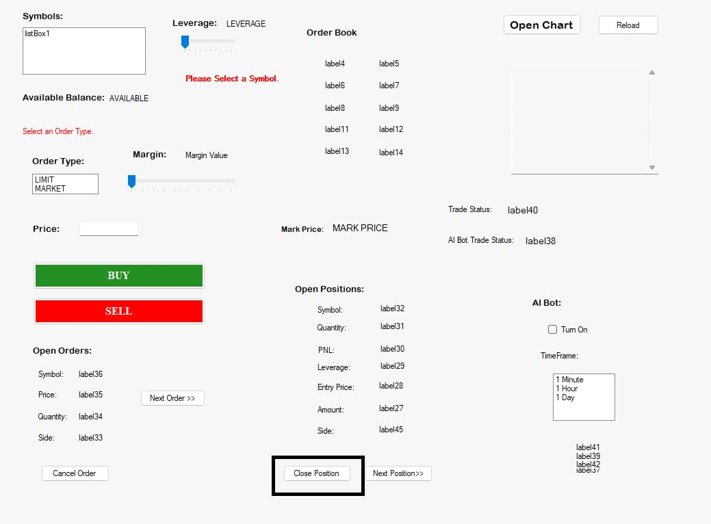

If user want to close the position at the current mark price, he can do it by clicking on this button. The position would be cancelled and a message would be shown on the Trade Status bar. If the trade was successful then the trade would also be stored in the Trades.csv file created in the installation directory.

**Next Position Button:**

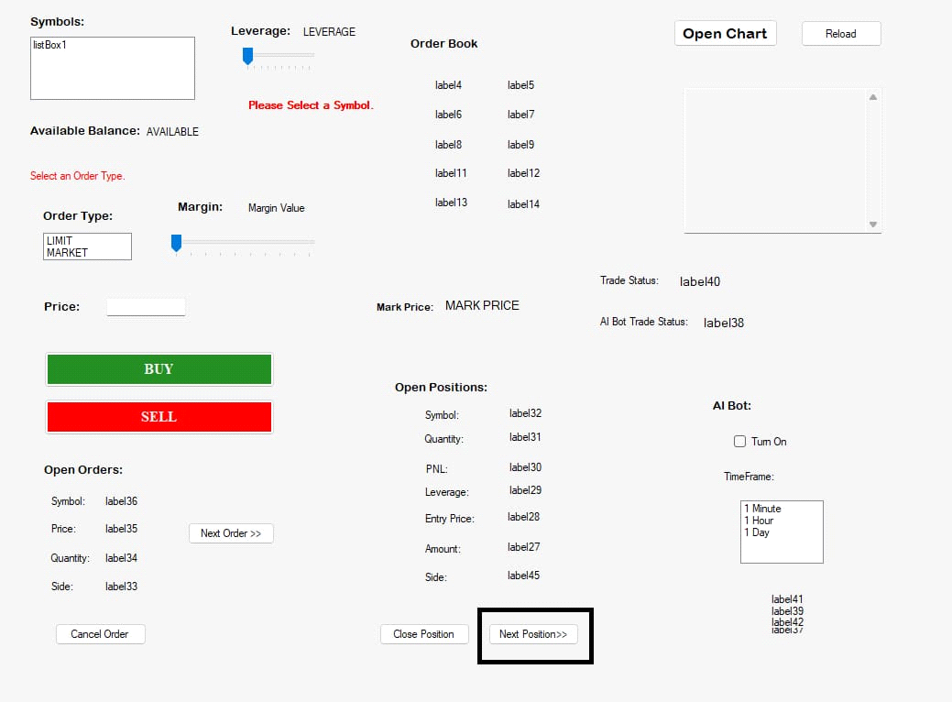

User can move to next open position by clicking on next position button.

**Open Chart Button:**

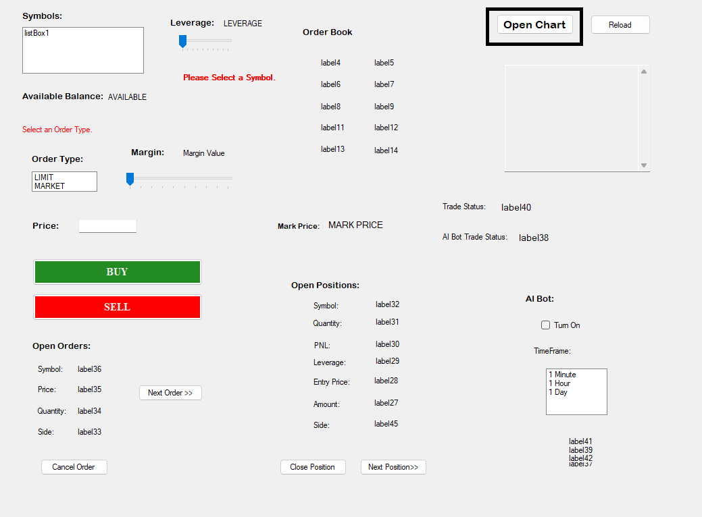

This button opens the chart of the selected symbol in the browser. This button remains locked until a valid symbol is selected.

**Reload Button:**

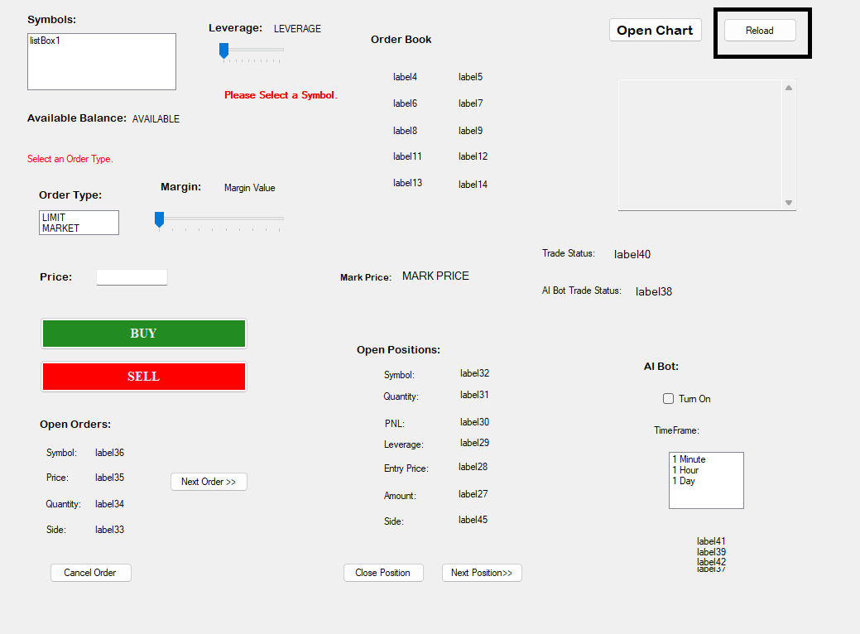

This will restart the program. If you facing any permanent issues, try reloading.

**On-Screen Logs:**

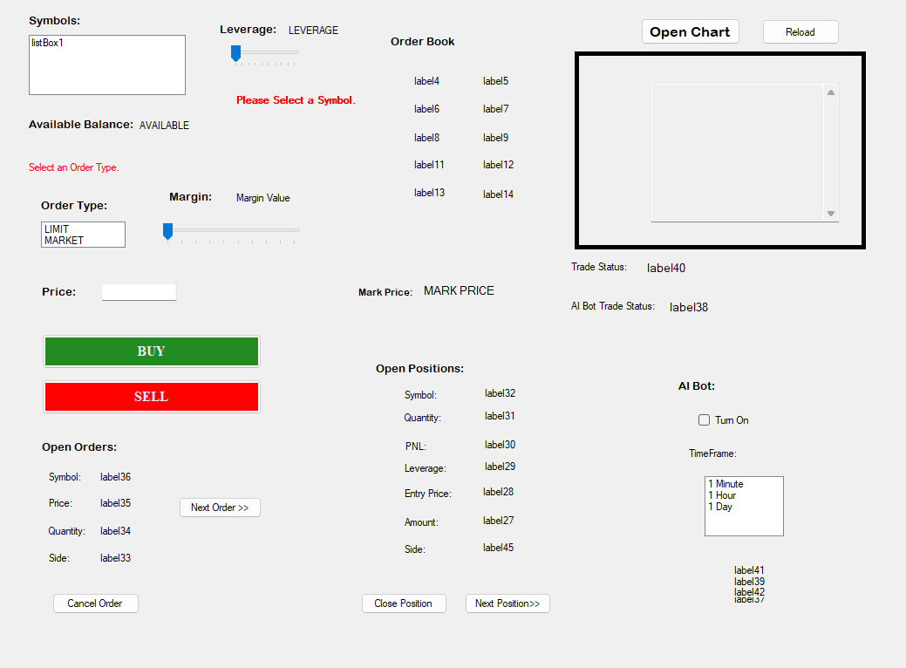

This shows the current operations of performed successfully or unsuccessfully by the program.

**Trade Status Bar:**

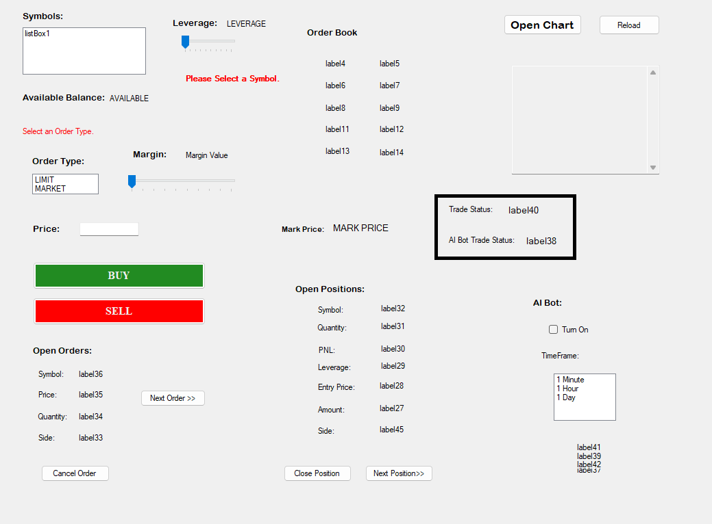

This shows the status of the trades by the user of by the AI. It shows it in green if successful otherwise in red.

**AI Options:**

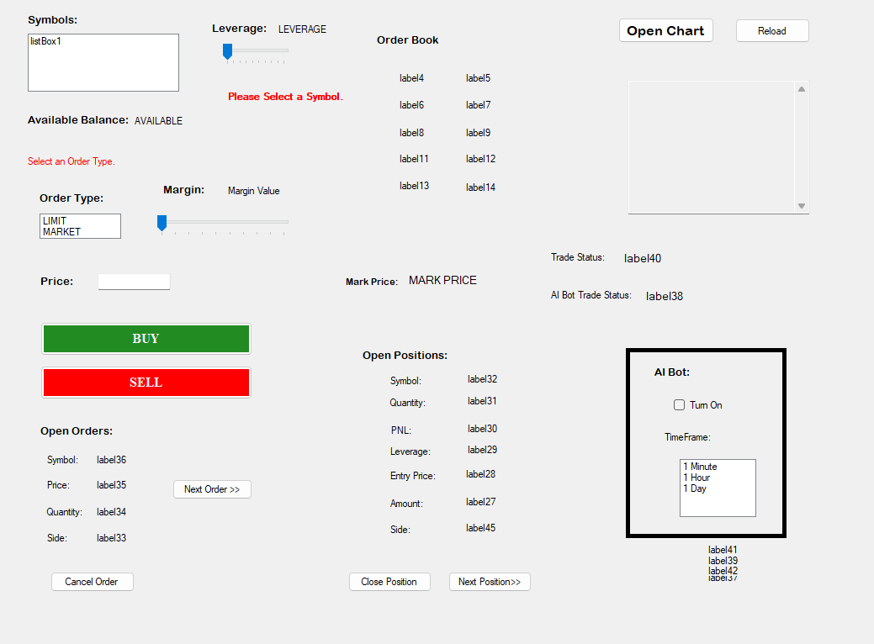

The AI bot can be switched on from here. The “Turn On” checkbox remains disabled until a valid symbol is selected. Once the check box is checked the user will also be able to select the timeframe. Once the user clicks it, they will be asked if they want to turn on the ai. If they click yes then they will be advised that the ai would take about 20 seconds to start, so please don’t turn off the program or your PC. After that the AI will be on and it will be able to place trades, when the conditions are right.